

Foundations of Programming

Assignment No.: 22
PROBLEM STATEMENT: Write a menu driven program in C to perform various string operations using in-built functions.

OBJECTIVE:

- To understand the concept of strings in the C programming language.
- To learn how to use built-in string functions for string manipulation.
- To perform operations such as length calculation, copying, concatenation, comparison, and reversal using menu options.

THEORY:
In the C programming language, a string is a sequence of characters terminated by a null character ('\0'). Strings are stored in character arrays and manipulated using functions available in the string.h header file.
Common built-in string functions include strlen() for finding the length of a string, strcpy() for copying one string to another, strcat() for concatenating two strings, and strcmp() for comparing two strings.
A menu driven program allows the user to select different operations from a list of options. Based on the user’s choice, the corresponding string function is executed. This approach makes the program interactive and easy to use.

Algorithm:
- Start
- Accept both strings and the choice ‘op’
- If op = 1, Return length of a
- If op = 2, return reverse of a
- If op = 3, return if a and b are the same
- If op = 4, return if a is a palindrome
- If op = 5, return if b is a substring of a.
- Stop

Code:
#include <stdio.h>
#include <string.h>

int main() {
char temp, a[50], aRev[50]={'\0'}, b[50];
int op;

printf("Enter string(s): ");
scanf(" %[^\n]s", a);
scanf(" %[^\n]s", b);

printf("What do you want to do?\n1. Check length of A\n2. Reverse A\n3. Check if A == B\n4. Check if A is a palindrome.\n5. Check if B is a substring of A.");
scanf("%d", &op);
int aLen = strlen(a);
for(int i = 0; i<aLen; i++){
aRev[i] = a[aLen-i-1];
}

switch(op){
case 1:
printf("'%s' is of the length %d \n", a, aLen);
break;
case 2:
printf("Reverse string of a: %s\n", aRev);
break;
case 3:
printf("both strings are ");
if(strcmp(a, b)) printf("NOT ");
printf("the same\n");
break;
case 4:
printf("A is ");
if(strcmp(a, aRev)) printf("NOT ");
printf("a Palindrome\n");
break;
case 5:
printf("b is ");
if(!strstr(a, b)) printf("NOT ");
printf("a substring of a\n");
break;
}
return 0;}
PLATFORM: Linux

INPUT: Two strings entered by the user.

OUTPUT: Displays results of different string operations such as length, copy, concatenation, and comparison.

SAMPLE INPUT:
Enter first string: Hello
Enter second string: World
Choice: 3

SAMPLE OUTPUT:
Concatenated string: HelloWorld
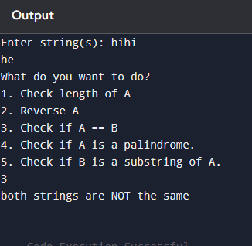

CONCLUSION: Thus, the C program successfully demonstrates different string operations using built-in functions through a menu driven approach, making the program interactive and easy to use.

FAQs:
- What are built-in string functions in C and why are they used?
- What is the purpose of the string.h header file in C programs?
- How does a menu driven program improve user interaction in programming?

